FitQuest Design Document

Developer: Alexandru Mazilu

**1. System Overview**

**FitQuest** is a scalable and secure fitness tracking application that enhances the interaction between users, trainers, and administrators. The system provides personalized workout plans and a comprehensive dashboard for each user role. The platform is built using modern web technologies such as **React.js** for the frontend, **Spring Boot** for the backend, and **MySQL** for the database, ensuring performance, security, and data integrity.

**2. Architecture Overview**

FitQuest is designed to be modular and scalable, divided into three main tiers: Frontend, Backend, and Database. The architecture supports multiple roles, including clients, trainers, and administrators, with each role having access to tailored features. The platform also supports real-time notifications via WebSockets.

**2.1 C1 Diagram (System Context)**

The C1 diagram shows the overall system, highlighting interactions between users (clients, trainers, and admins) and the FitQuest platform.

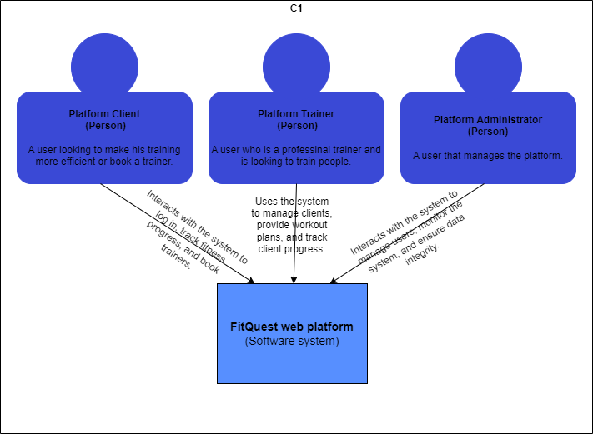

**2.2 C2 Diagram (Container Diagram)**

This diagram breaks down the system into key containers, showing how the web application (React.js + Springboot) and database (MySQL) communicate with each other.

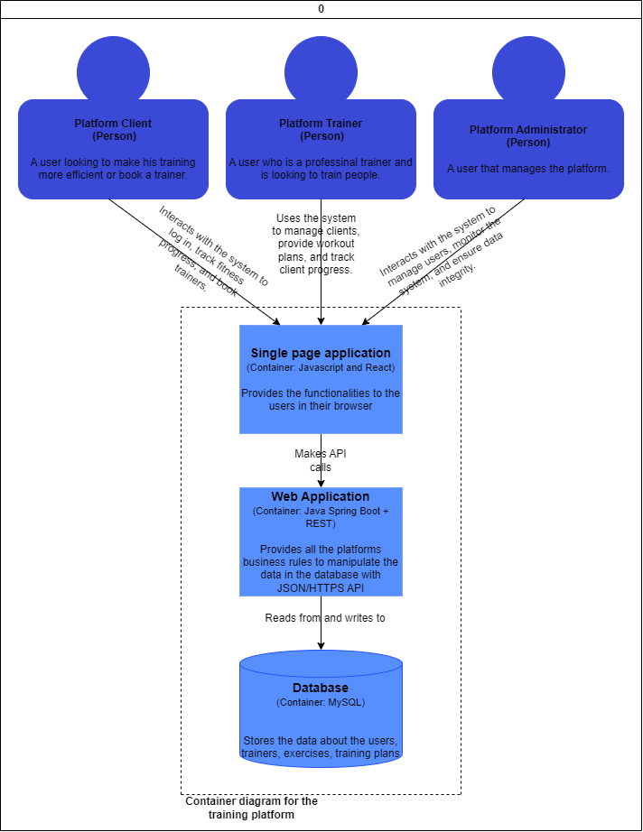

**2.3 C3 Diagram (Component Diagram)**

The C3 diagram provides a more detailed view of the system’s internal structure, showing the individual components within the backend, including the authentication service, the profile system, the workout service, and the activity service.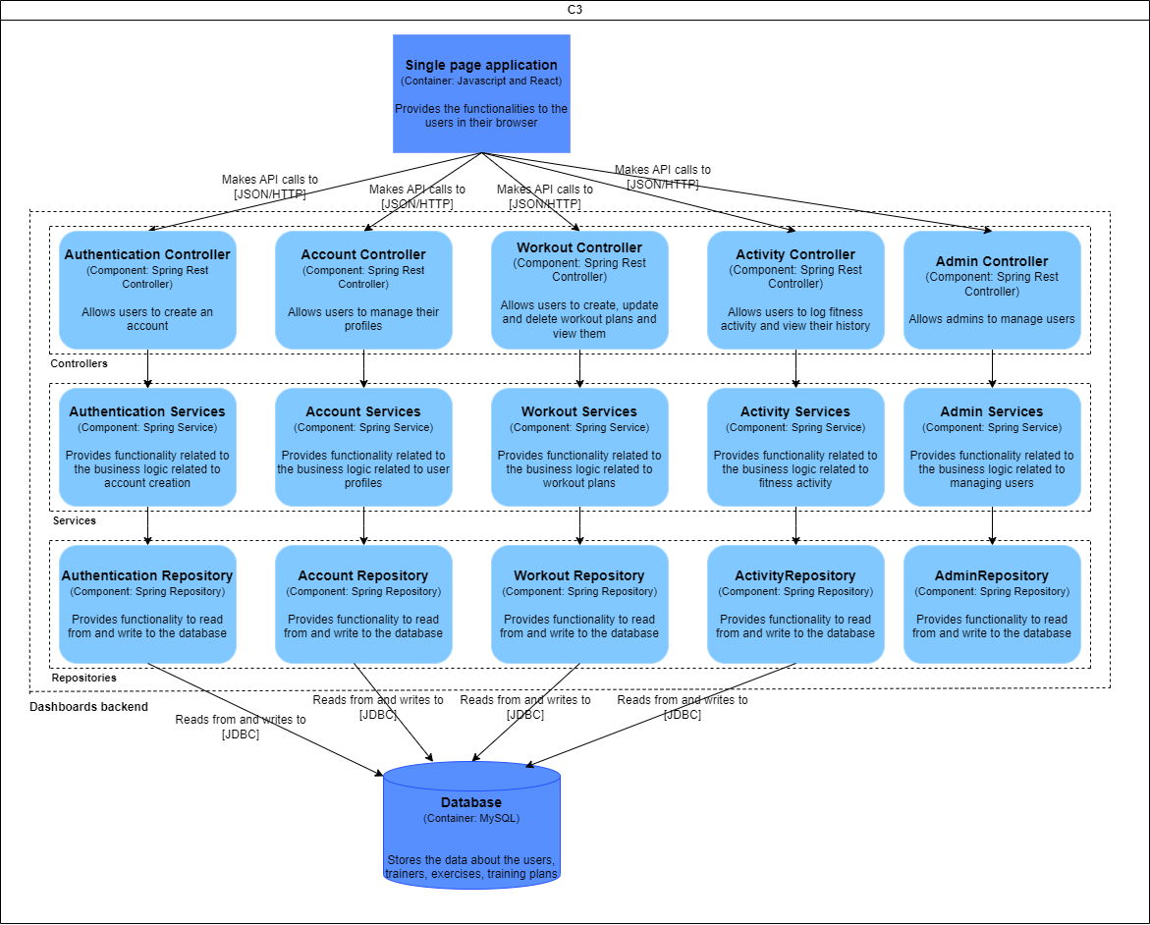

**2.4 C4 Diagram (UML) for FitQuest**

The C4 diagram provides a more detailed view of the system’s internal structure, breaking down the backend into individual components. These include the admin component, responsible for user management for admins, authentication component, responsible for user verification; the account component, managing user information; the workout component, handling exercise data and routines; and the activity component, tracking user workouts and progress. A diagram of a computer

**3. Design Decisions**

**3.1 Frontend: React.js**

**Chosen because**: React.js is a highly interactive, component-based framework, ideal for developing complex user interfaces like dashboards for different user roles (clients, trainers, admins). It allows efficient state management and reusable UI components.

**3.2 Backend: Spring Boot**

**Chosen because**: Spring Boot provides a fast setup and robust framework for developing secure and scalable backend services. It supports microservices architecture, which will be beneficial for future scaling and modularity.

**3.3 Database: MySQL**

**Chosen because**: MySQL is a widely-used relational database management system, ideal for handling structured data and offering excellent support for transactions, making it perfect for managing user data, workout logs, and system records.

**4. Architecture Constraints**

**4.1 Performance Constraints**

* **Real-time features**: The system must support real-time updates with minimal latency, particularly for trainer-client interactions and notifications.
* **Load Handling**: The application should support up to **1,000 simultaneous users** and handle **100 transactions per second**.

**4.2 Scalability Constraints**

* **Horizontal scaling**: The architecture must support horizontal scaling to handle increases in user traffic.
* **Future integrations**: The architecture should allow the integration of additional features without significant modifications.

**4.3 Security Constraints**

* **Data protection**: FitQuest must comply with **GDPR** and ensure the security of all user data, including encryption for sensitive information like passwords.
* **Role-based access**: Different roles (clients, trainers, admins) must have strict access controls to ensure that data is protected and accessible only to authorized users.

**4.4 Technology Constraints**

* **Open-source technologies**: The project must rely on open-source tools to stay within budget, which means avoiding proprietary licenses for software and cloud services unless absolutely necessary.

**5. Component Design**

**5.1 Authentication and Authorization**

* **Purpose**: The system must securely authenticate users (clients, trainers, and admins) and ensure appropriate access to resources based on roles.
* **Design**: FitQuest will use **Spring Security** with **JWT (JSON Web Tokens)** for handling authentication. Role-based access controls will be enforced through the backend.

**5.2 Dashboard Modules**

* **Client Dashboard**: Displays workout plans, progress tracking, and notifications. Users can log workouts and track their progress over time.
* **Trainer Dashboard**: Displays client lists, assigned workout plans, and notifications for real-time interactions.
* **Admin Dashboard**: Provides system monitoring capabilities, including user and exercise management.

**5.3 Real-Time Notifications**

* **Purpose**: Trainers and clients must receive notifications about workout updates or progress in real-time.
* **Design**: A **WebSocket server** will handle real-time data, pushing notifications directly to user dashboards. This service will also be scalable, ensuring minimal delay for high volumes of traffic.